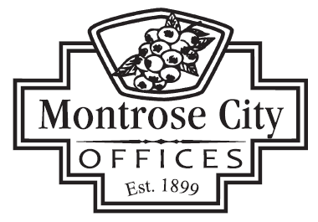

139 S. SAGINAW STREET MONTROSE, MI 48457 / PHONE (810) 639-6168

DOWNTOWN DEVELOPMENT AUTHORITY BOARD (D.D.A.)
May 21, 2026 @ 7:30 a.m.
CALL TO ORDER
ROLL CALL
PLEDGE OF ALLEGIANCE
APPROVAL OF AGENDA
CITIZEN COMMENTS
The purpose of this agenda item is to allow persons to comment. This is not a forum for debate or for which questions will be answered. The Board will consider all comments and questions and decide if they wish to address those items during board comments. All persons addressing the DDA Board are asked to limit their comments to no more than three (3) minutes.

CONSENT AGENDA
- Approval of April 16, 2026 D.D.A. Meeting Minutes (DRAFT)

PRESENTATION

OLD BUSINESS
NEW BUSINESS
- Consider Approving FY26/27 Budget Resolution
- Consider discussion of DDA Logo and Branding

BID AWARD/PURCHASE

ORDINANCES

APPOINTMENTS

CITIZEN COMMENTS
The purpose of this agenda item is to allow persons to comment. This is not a forum for debate or for which questions will be answered. The Board will consider all comments and questions and decide if they wish to address those items during board comments. All persons addressing the DDA Board are asked to limit their comments to no more than three (3) minutes.

DDA COMMITTEE REPORTS
- DDA Chairwoman: Verbal report - “Event Committee”

CITY MANAGER / DDA BOARD MEMBER COMMENTS

ADJOURNMENT

Next DDA Meeting – June 18, 2026 at 7:30 a.m.

